**Retrieve Provider**

**Retrieve Provider**

1. Search for Provider:

**Anthem Provider Management**

NP ID:

Zip Code:

John Smith

Provider Name:

Specialization:

Physiotherapist

Search

Cancel

**Business Rules:**

Search should be based on combination of inputs.

1. On click of Search:

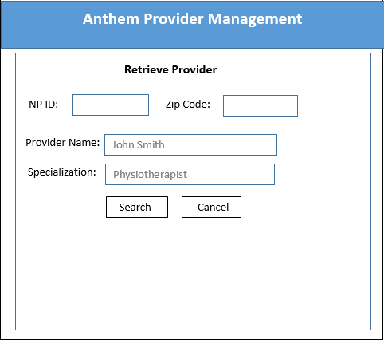

|  |  |  |  |  |
| --- | --- | --- | --- | --- |
| NP ID | Provider Name | Specialization | Zip Code | Status |
|  |  |  |  |  |
|  |  |  |  |  |
|  |  |  |  |  |